Group2
Jasmine Fontus
Noah McCarthy
Suresh Shrestha
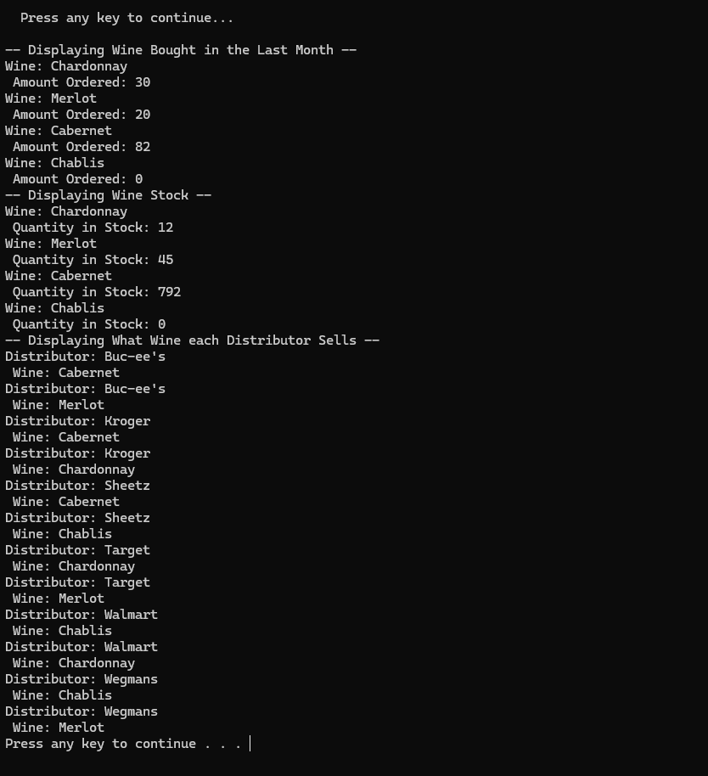
- The wine distribution, are all wines selling as they thought? Is one wine not selling? Which distributor carries which wine?

Suppliers delivery Report

